Assignment – Decision Trees

Rogov Sergei

Activity 1

1. b)

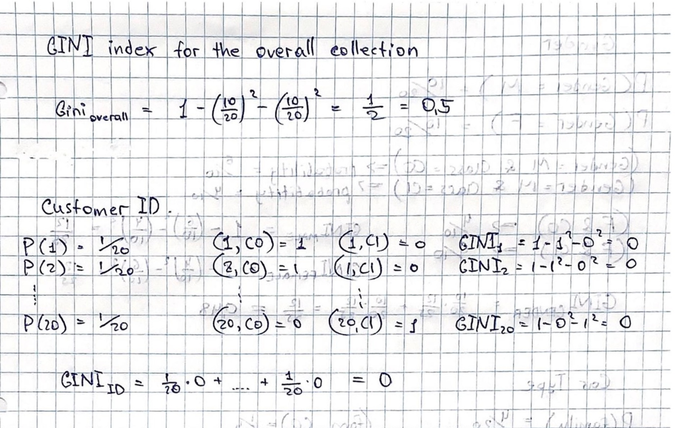

1. d) e)

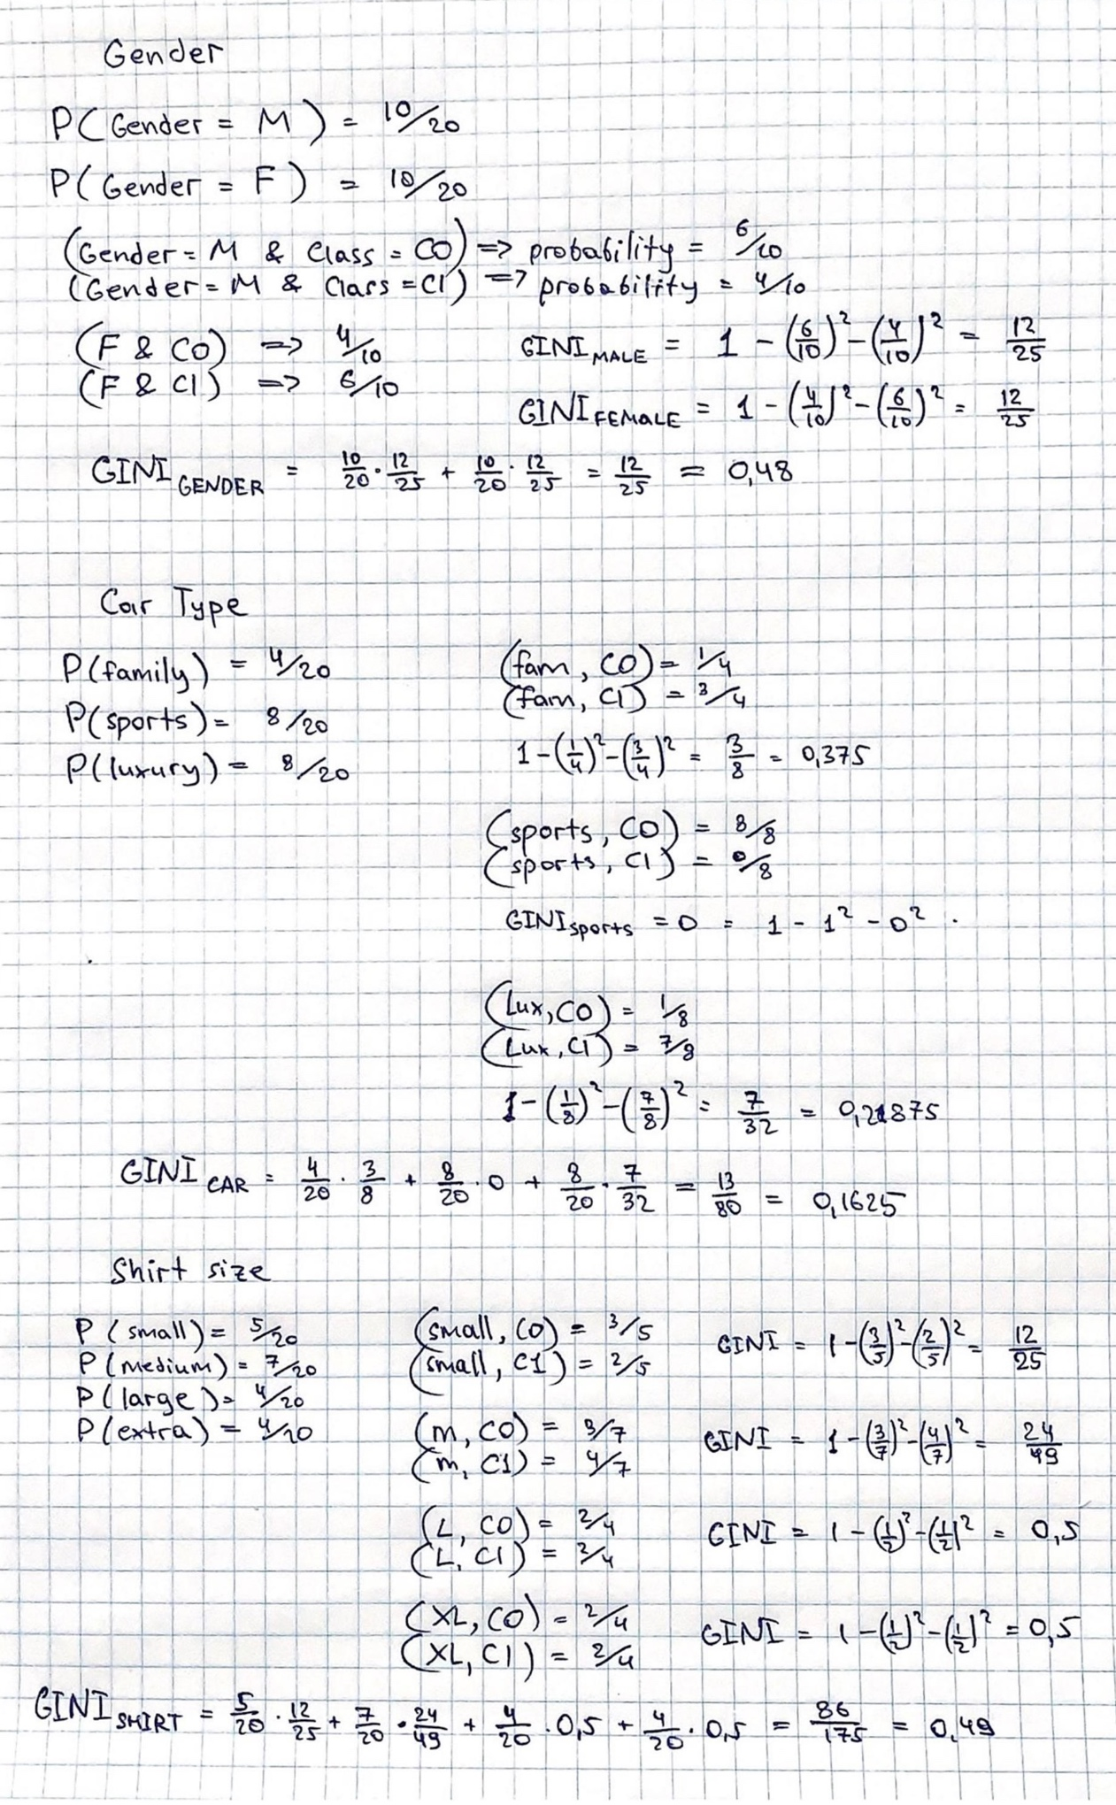

f) Car Type is the best attribute since it has the lowest Gini index (0.1625) from these three attributes. [Gender is 0.48 and Shirt Size is 0.49]

g) Every customer is assigned to a unique ID number, that is why this attribute should not be considered. Customer ID attribute is not predictive.